Exp :27 Binary Semaphore in SystemC
Program:
// Code your testbench here.
// Uncomment the next line for SystemC modules.
// #include <systemc>
#include <systemc.h>
SC_MODULE(binary_semaphore) {
int sem; sc_event ev; void task1() { while(true) { wait(1, SC_SEC); if(sem == 1) {
sem = 0;
cout << "Task1 Entered Critical Section at " << sc_time_stamp() << endl; wait(2, SC_SEC); sem = 1; ev.notify();
} else { wait(ev);
}
}
}

void task2() { while(true) { wait(2, SC_SEC); if(sem == 1) { sem = 0;
cout << "Task2 Entered Critical Section at " << sc_time_stamp() << endl; wait(1, SC_SEC); sem = 1; ev.notify();
} else { wait(ev);
}
}
}

SC_CTOR(binary_semaphore) {
sem = 1;
SC_THREAD(task1); SC_THREAD(task2);
}
};
int sc_main(int argc, char* argv[]) { binary_semaphore obj("Binary_Semaphore"); sc_start(10, SC_SEC); return 0;
}
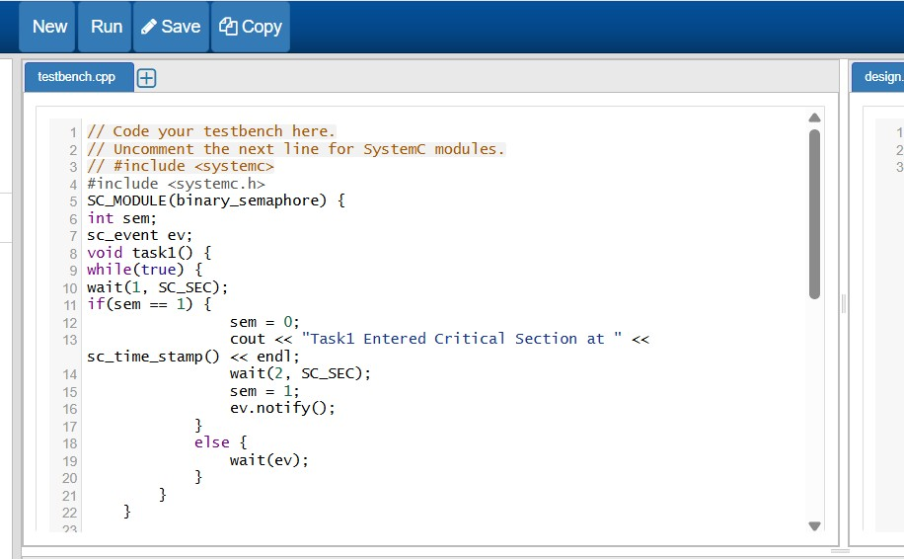
OutPut
